Name: Hillary Johnson Semester: Summer 2016
ESSENTIAL CONDITION ONE: Effective Instructional Uses of Technology Embedded in Standards-Based,
Student-Centered Learning

ISTE Definition: Use of information and communication technology (ICT) to facilitate engaging approaches to learning.
Guiding Questions:
- How is technology being used in our school? How frequently is it being used? By whom? For what purposes?
- To what extent is student technology use targeted toward student achievement of the Georgia Learning Standards (GPSs, CCSs)?
- To what extent is student technology use aligned to research-based, best practices that are most likely to support student engagement, deep understanding of content, and transfer of knowledge? Is day-to-day instruction aligned to research-based best practices?
Strengths | Weaknesses | Opportunities | Threats
- Teachers use various technology in their classrooms: projectors, laptops, DVD players, formative assessment remotes | - iRespond problems  - No staff support for technology integration | - Professional development  - Teacher to teacher staff support | - Funding for technology  - Administration doesn’t make integration a priority
Summary/Gap Analysis:

Technology is frequently used in our school but some improvement could be made as far as the specific type of use and the quantity of use. Many teachers report using technology multiple times a day in the classroom, but there is a disconnect between student achievement and purposeful technology use. Most teachers feel comfortable using their classroom projectors, DVD players, and iRespond remotes and many teachers also check out laptops for student use during a technology-rich lesson. The problem with this technology use is that iRespond has several issue and cannot be trusted as a reliable piece of technology, especially for those teachers that use it frequently as a formative assessment tool. In addition, there is not really any support for staff who integrate technology into their classrooms. Teachers that choose particular technology tools are on their own in terms of learning how to implement the technology and troubleshooting any issues that may occur.

Teachers need support to aid in technology integration in the classroom. Most teachers still teach in a lecture format and the learning is not student-centered to better engage students in their learning. Teachers will need assistance to implement technology in a manner that supports student learning and engagement to make their classrooms student-centered. Some teachers in the building that are comfortable with technology integration can be mentors for teachers that need a little more assistance. Professional development is another option to show teachers how to use the technology, but teachers will still need support during the implementation process for any issues that may arise. Administration also needs to make hands-on technology learning a priority in our building and support those teachers that already do this kind of classroom learning while encouraging more teachers to use this approach in their classrooms.

Data Sources:

Responses from the Survey Instrument (in Appendix) created by H. Johnson

ESSENTIAL CONDITION TWO: Shared Vision

ISTE Definition: Proactive leadership in developing a shared vision for educational technology among school personnel, students, parents, and the community.
Guiding Questions:
- Is there an official vision for technology use in the district/school? Is it aligned to research-best practices? Is it aligned to state and national visions? Are teachers, administrators, parents, students, and other community members aware of the vision?
- To what extent do teachers, administrators, parents, students, and other community members have a vision for how technology can be used to enhance student learning? What do they believe about technology and what types of technology uses we should encourage in the future? Are their visions similar or different? To what extent are their beliefs about these ideal, preferred technology uses in the future aligned to research and best practice?
- To what extent do educators view technology as critical for improving student achievement of the GPS/CCSs? To preparing tomorrow’s workforce? For motivating digital-age learners?
- What strategies have been deployed to date to create a research-based shared vision?
- What needs to be done to achieve broad-scale adoption of a research-based vision for technology use that is likely to lead to improved student achievement? Explain how will you advocate for a solution.
Strengths | Weaknesses | Opportunities | Threats
- Staff are willing to implement new technology  - Teachers encourage student achievement through technology | - School does not have a shared vision  - All staff members are on a different page for the school vision for technology | - School can create a shared vision  - All stakeholders can invest in the vision | - All stakeholders, administrators, and teachers need to be on the same page and are currently not with varying degrees of interest and experience.
Summary/Gap Analysis:

The school does not currently have a shared vision in place nor is there one planned to be implemented in the future. Even without a shared vision, according to the survey data, the current staff are ready and willing to implement new technology or further refine the technology they already use in the classroom. Many teachers also encourage increased student achievement through technology but many teachers do not feel supported in their technology use. The lack of a shared vision makes it difficult to unite staff members on the same level for technology integration.

To unite all staff members, first and foremost, the school needs to create a shared vision for technology. This vision needs to include implementation goals and address the ISTE Student Standards to provide an equal opportunity learning environment for the students. All stakeholders need to be invested in this vision so that everyone involved feels they have an active role in the implementation process. According to the ISTE diagnostic tool, the school is in the beginning stages of developing a shared vision. Based on the data survey responses, many teachers and administrators have the same ideas when it comes to a shared vision and that is one where all students have technology access in the classroom. Most teachers also suggested that ideally every student would have a laptop. The gap is that many teachers want a technology plan in place with a shared vision and are more than prepared to implement it but the administration and other stakeholders have not developed a shared vision to use to pursue this implementation.

Data Sources:

Lead and Transform Diagnostic Tool on the ISTE site (results in the appendix)
Responses from the Survey Instrument (in Appendix) created by H. Johnson

ESSENTIAL CONDITION THREE: Planning for Technology

ISTE Definition: A systematic plan aligned with a shared vision for school effectiveness and student learning through the infusion of ICT and digital learning resources.
Guiding Questions:
- Is there an adequate plan to guide technology use in your school? (either at the district or school level? Integrated into SIP?)
- What should be done to strengthen planning?
- In what ways does your school address the needs of diverse populations in the school or district to include how race, gender, socio-economic, and geographic diversity giving consideration to how these factors commonly affect K-12 students’ access to school and beyond-school access to high-speed Internet, modern computing devices, software, knowledgeable technology mentors, culturally-relevant digital content, and other affordances critical to technology literacy acquisition.
Strengths | Weaknesses | Opportunities | Threats
- New, updated laptops for teacher use  - Expanded media center hours (7-5 every day) | - Lack of internet access for low SES students  - Lack of STEM involvement for girls  - No tech plan to guide equal access and implementation | - BYOD laptop community  - Provide more teacher laptop carts  - Apply for grants and awards to provide for students who cannot afford technology | - School does not make technology a priority  - School needs adequate money to fund technology implementation in the school.
Summary/Gap Analysis:

The current plan in place has continued to add new, updated laptops on carts to the media center for teacher check-out. The media center has also added more desktop computers and has expanded hours from 7am to 5 pm each day for student access. There is also a BYOD network in place. In addition, over the summer the school has installed wireless access points (WAPs) in each classroom for better, more reliable internet use when teachers have the laptop carts in their classroom. According to the survey, many teachers are aware of these improvements, but no one really knows about the actual technology plan in place and what is consists of in terms of improving the school. New white boards with “beams” were also installed last year but many teachers don’t know how to use them and other classrooms didn’t even get these beams because the installation staff could not fit them into these teacher’s classrooms.

To strengthen planning in the future, a plan needs to be in place to ensure equitable access for all students both in and out of the classroom. Many students do not have personal devices, so the school would benefit from a rent-to-own program or loaning out these devices for student use at home. In addition, more laptop carts need to be provided for teacher access. There over 75 teachers in the school and only three laptop carts to be shared. Cart checkouts are first come, first serve and teachers need to plan their “technology use days” months in advance to have access to the carts. According to the ISTE survey, planning is in the beginning stages and has the most room for improvement. All stakeholders need to discuss and agree on a common technology plan that everyone is invested in. The current plan is not available for teachers, parents, or students to view and administration does not seem to want to involve anyone else in the planning process.
Data Sources:

Lead and Transform Diagnostic Tool on the ISTE site (results in the appendix)
Responses from the Survey Instrument (in Appendix) created by H. Johnson

ESSENTIAL CONDITION FOUR: Equitable Access (Specifically address low SES and gender groups – ie. females.)

ISTE Definition: Robust and reliable access to current and emerging technologies and digital resources.
Guiding Questions:
- To what extent do students, teachers, administrators, and parents have access to computers and digital resources necessary to support engaging, standards-based, student-centered learning?
- To what extent is technology arrange/distributed to maximize access for engaging, standards-based, student-centered learning?
- What tools are needed and why?
- How will you advocate in regard to digital equity issues among low SES and gender groups (ie. females)?
- Do students/parents/community need/have beyond school access to support the shared vision for learning?
Strengths | Weaknesses | Opportunities | Threats
- Expanded media center hours (7-5)  - Staff support for students without resources to access classroom materials. | - Not enough laptops or resources for every student to have one.  - Staff does not acknowledge there is an equitable access issue. | - More female access and encouragement for enrolling in STEM  - More teacher support for low-income students | - Teachers do not have the knowledge to support students  - Staff support will also be needed to help students with knowledge.
Summary/Gap Analysis:

The current equitable access ideas in place do not support low SES students and gender groups. After surveying staff members, everyone seems to think that the expanded media center hours (7am-5pm) are enough to support all students. Some teachers do provide individual support for low SES and gender groups within their classrooms, but this is only a few teachers out of over 75 teachers in the school. The school struggles to provide enough resources for each student to have access. There are only several laptop carts available for teachers to use in their classrooms and even though many students bring their own devices to school, the BYOD network does not support the large amounts of student devices on the network at the same time. The new wireless access points will be great for laptop carts but these points will not help improve BYOD device access.

The current programs at the school also do not encourage low SES and gender groups to participate in accelerated pathways. The new STEM program at the school needs to encourage more low SES and females to enroll in the program. According to Boser (2013), students from low socioeconomic backgrounds tend to have less exposure to using technology for higher-level thinking skills. This lack of exposure could cause these students to shy away from even attempting to apply for the STEM program because they feel they are inadequate. For this reason, teachers need to seek out and encourage these students to rise to the challenge and apply for the STEM program. According to the ISTE survey, the school is in the meeting stages of equitable access, but this is largely because a majority of students come from higher income families and have the technology needed to be successful in the classroom, so the school really hasn’t had to provide technology for students that cannot provide it on their own.

Data Sources:
Boser, U. (2013). Are schools getting a big enough bang for their education technology buck? Center for American Progress, 1-10.
Lead and Transform Diagnostic Tool on the ISTE site (results in the appendix)
Responses from the Survey Instrument (in Appendix) created by H. Johnson

ESSENTIAL CONDITION FIVE: Skilled Personnel

ISTE Definition: Educators and support staff skilled in the use of ICT appropriate for their job responsibilities.
Guiding Questions:
- To what extent are educators and support staff skilled in the use of technology appropriate for their job responsibilities?
- What do they currently know and are able to do?
- What are knowledge and skills do they need to acquire?

(Note: No need to discuss professional learning here. Discuss knowledge and skills. This is your needs assessment for professional learning. The essential conditions focus on “personnel,” which includes administrators, staff, technology specialists, and teachers. However, in this limited project, you may be wise to focus primarily or even solely on teachers; although you may choose to address the proficiency of other educators/staff IF the need is critical. You must include an assessment of teacher proficiencies.)
Strengths | Weaknesses | Opportunities | Threats
- Consistent teacher blogs  - Teachers try new tools in the classroom | - Use of formative assessment tools  - Staying consistent with the implementation of new tools and give up too easily | - Convert teacher blogs from blogs to learning management systems  - Teachers can incorporate more technology tools | - Teachers are “set in their ways” and are hesitant to use new technology  - Teachers do not have enough time to learn new tools.
Summary/Gap Analysis:

All teachers at the school consistently maintain and update teacher blogs to communicate with students and parents. Many teachers also try new tools in the classroom and use formative assessment tools such as Kahoot, Socrative, and Quizizz to keep students engaged in the classroom content. Despite this use, many teachers do not use technology in the classroom and those that do give up too easily if something goes wrong. All teachers are currently able to use Synergy (the grading system), Typepad (the blog platform), and Office 365 without much of an issue or needing any tech support. Beyond this, most teachers do not feel comfortable enough implementing other technology tools and devices. Many teachers collect cell phones during class and do not allow students to use them in the classroom which completely prohibits the use of technology in the classroom.

Teachers can improve in many areas of skill. First, teachers would benefit from using an entire learning management system for their classrooms such as Edmodo, Schoology, Google Sites, Weebly, etc. rather than just posting updates on a blog each week. In this manner, the students would be more engaged in the classroom and also be more efficient when doing work outside of the classroom. According to the survey responses, many teachers think that by putting laptops in every classroom or by having each student have a laptop that the technology issues will be solved. The issue is that a majority of teachers do not know how to implement classroom laptops effectively now. Teachers will need to gain the skills to be comfortable in teaching with technology and creating meaningful instruction for the students.

Data Sources:

Lead and Transform Diagnostic Tool on the ISTE site (results in the appendix)
Responses from the Survey Instrument (in Appendix) created by H. Johnson

ESSENTIAL CONDITION SIX: Ongoing Professional Learning

ISTE Definition: Technology-related professional learning plans and opportunities with dedicated time to practice and share ideas.
Guiding Questions:
- What professional learning opportunities are available to educators? Are they well-attended? Why or why not?
- Are the current professional learning opportunities matched to the knowledge and skills educators need to acquire? (see Skilled Personnel)
- Do professional learning opportunities reflect the national standards for professional learning (NSDC/Learning Forward)?
- Do educators have both formal and informal opportunities to learn?
- Is technology-related professional learning integrated into all professional learning opportunities or isolated as a separate topic?
- How must professional learning improve/change in order to achieve the shared vision?
Strengths | Weaknesses | Opportunities | Threats
- “Choose your own” professional development opportunities  - Technology is evenly integrated into content professional development. | - Teachers are not mandated to attend professional development  - Teachers are not supported during the implementation process | - Provide teachers with a program for support with technology implementation  - More professional development options and mandate a certain amount each year | - Teachers do not like to be told what to do  - Teacher buy-in must occur
Summary/Gap Analysis:

Current professional development opportunities provided for teachers give them a whole spectrum of choices. Teachers basically get to choose their own professional development opportunities and attend as many or as few as they desire. The professional development that is offered has technology evenly integrated into it, but many teachers feel overwhelmed after leaving these sessions. While administration does not require professional development attendance throughout the school year, many teachers still choose to go and learn something new or refine their current practice. According to the Learning Forward Standards for Professional Learning (2011), educators must come to professional learning opportunities ready to learn. In addition professional learning opportunities must be able engage all educators who are attending the professional development with various levels of knowledge of the topic. According to survey data, teachers that do attend professional development are happy with the technology they are learning and are engaged in the learning process, but don’t feel supported during the implementation process after they leave the professional development. In most cases, the teachers quickly learn about a tech tool and then have to figure out how it works and the best way to implement it on their own. While this may work for some teachers, other teachers who are not very tech savvy in general get easily overwhelmed and frustrated and just go back to the non-technology method of teaching in their classrooms. Others in the survey also cited that technology training should be "pushed” more within the school. There are several “lunch and learns” held throughout the school year but these are optional to attend and attendees are usually bribed to attend with the promise of a free meal.

Future professional learning needs to provide a support program for teachers who choose to implement these tech tools. Other teachers within the building that are comfortable with using the tools or programs can be mentors to teachers that would like to use the tool but do not have the support to properly implement it in their classroom. In addition, more professional development needs to be offered to provide teachers with the support they need for the implementation process, not just the introduction of the tool. In addition, a certain amount of professional development should be mandated each year to ensure that all teachers are getting exposure to the technology that is available for classroom use as well as the importance of using technology in the classroom to enhance student learning.

Data Sources:

Lead and Transform Diagnostic Tool on the ISTE site (results in the appendix)
Learning Forward. (2011). Standards for professional learning. Retrieved from https://learningforward.org/docs/august-2011/referenceguide324.pdf?sfvrsn=2
Responses from the Survey Instrument (in Appendix) created by H. Johnson

ESSENTIAL CONDITION SEVEN: Technical Support

ISTE Definition: Consistent and reliable assistance for maintaining, renewing, and using ICT and digital resources.
Guiding Questions:
- To what extent is available equipment operable and reliable for instruction?
- Is there tech assistance available for technical issues when they arise? How responsive is tech support? Are current “down time” averages acceptable?
- Is tech support knowledgeable? What training might they need?
- In addition to break/fix issues, are support staff available to help with instructional issues when teachers try to use technology in the classroom?
Strengths | Weaknesses | Opportunities | Threats
- Quick help to fix or repair broken technology  - Tech specialist is located on site and readily available  - More new desktops & laptop carts are being added to the school each year with updated programs added by the tech specialist | - No help for instructional issues with implementation  - Tech specialist is not knowledgeable in tech tools and classroom use  - Many of the laptops available in the school are in poor working order | - Hire an additional instructional technology coach to help teachers  - More training and ongoing support for the use of technology tools | - Not enough resources available for all teachers to use  - Many teachers “check out” the resources but don’t use them to their full potential
Summary/Gap Analysis:

Current technical support is basic and simple at most. Requested repair for damaged devices or troubleshooting help is always quick and usually fixes the problem from the local level as the technology specialist has an office in the school. If the technology problem must be repaired from the district level, repairs can take days if not weeks to be fixed, as has happened with projector issues in the past. The current technology specialist is great at troubleshooting program issues and computer problems but has minimal knowledge about the latest tech tools and apps that students and teachers use within their classrooms. Teachers surveyed cited that more help and assistance is needed in every day implementation.

Moving forward, an additional instructional coach needs to be added to the staff to help teachers with proper implementation of technology in the classroom. This additional technology coach could provide the ongoing support teachers are requesting. The current technology specialist also needs additional training to be able to support teachers in their classroom technology use. Teachers also need training to support other teachers in the implementation process. Teachers could become instructional leaders in the school to help lighten the load of the technology specialist and provide more individualized help to teachers in need.

Data Sources:

Lead and Transform Diagnostic Tool on the ISTE site (results in the appendix)
Responses from the Survey Instrument (in Appendix) created by H. Johnson

ESSENTIAL CONDITION EIGHT: Curriculum Framework

ISTE Definition: Content standards and related digital curriculum resources.
Guiding Questions:
- To what extent are educators, students, and parents aware of student technology standards? (ISTE Standards for Students)
- Are technology standards aligned to content standards to help teachers integrate technology skills into day-to-day instruction and not teach technology as a separate subject?
- To what extent are there digital curriculum resources available to teachers so that they can integrate technology into the GPS/CCS as appropriate?
- How is student technology literacy assessed?
Strengths | Weaknesses | Opportunities | Threats
- New teachers have more knowledge and are better at integrating technology in the classroom  - New teachers provide support and help troubleshoot for older teachers | - Teachers have a minimal awareness of the ISTE standards for students  - Few digital curriculum resources are available for teacher classroom use  - Students are not held accountable for technology literacy and teachers do not assess for this literacy | - Technology coach can help teachers use the ISTE standards in the curriculum  - County-wide improvement for access and availability for digital resources | - Integrating technology standards are not a priority for administration  - Teachers feel they do not have enough time to add additional tasks to their workload
Summary/Gap Analysis:

In the past three years, many new teachers have been hired at the school and these teachers have had extensive training in technology implementation and bring new and exciting technology ideas to other staff members. These new teachers, despite being new to teaching, are able to provide support to older staff members when it comes to troubleshooting minor issues with these new tech tools. Despite the influx of new teachers with technology knowledge, a majority of teachers have minimal awareness of the ISTE student standards according to the teacher survey, and definitely do not implement these standards in their everyday teaching. In addition, students are not held accountable for digital citizenship issues by teachers and technology literacy is not assessed in any way. There are also few, if any, digital curriculum resources available from the district level.

For improvement in the future, the technology coach and other teachers that are comfortable using the technology standards, need to create a program that introduces the technology standards to teachers and helps teachers with the implementation of these student standards within the curriculum. From a county level, digital curriculum resources also need to be made available for teachers. Those teachers who are just starting their careers and even those that are teaching a new subject for the first time could benefit greatly from county-wide curriculum resources. A plan will need to be put in place by administration to make technology integration a priority and help teachers feel at ease instead of feeling as if their work load is growing and they don’t have enough time to be successful with classroom technology integration. Students should also be assessed for digital literacy throughout the school year. According to the ICT Student Standards for high school students, students should be able to design and develop an online learning game, design a website, model ethical behaviors, and be able to troubleshoot technology issues to name just a few of the standards. Grade-level teacher teams should examine these standards and determine which standards each subject will work on during the course of the school year. Then, each grade-level team can build onto the standards as students progress through high school to ensure students are graduating with strong digital literacy skills.

Data Sources:

Lead and Transform Diagnostic Tool on the ISTE site (results in the appendix)
National Educational Technology Standards for Students. (2007). Profiles for technology (ICT) literate students.
Responses from the Survey Instrument (in Appendix) created by H. Johnson

Appendix

Lead and Transform Diagnostic Tool on the ISTE site

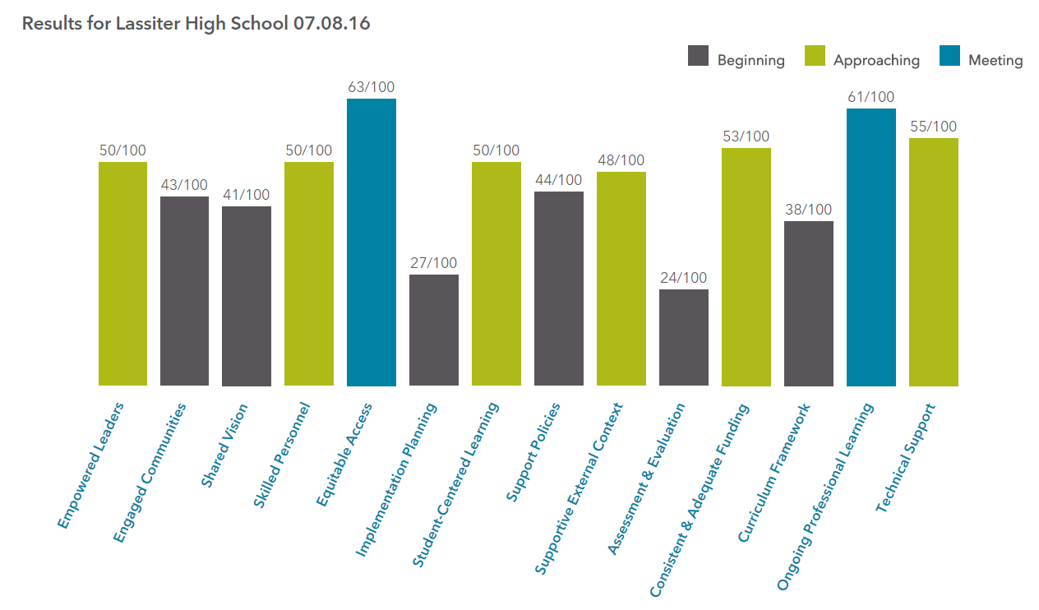

Responses from the Survey Instrument

- How frequently do you use technology in the classroom?

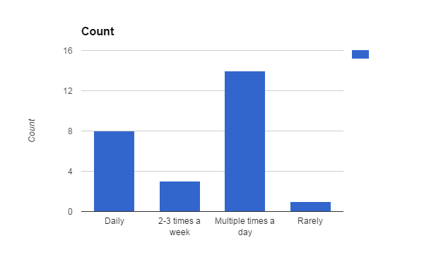
2. In your experience with our school's BYOD environment, what improvements do you think could be made?

Capability for teachers to unlock websites when needed for educational purposes.
Ipads
Free up some of the web blocking; give all students emails
Improved accountability for off-task technology behavior
More accessibility to sites as many are blocked.
Cobb has to make different computer platforms work at school
The BYOD internet needs to be faster and more reliable. As it is now, it's not really functional.
Overall good BYOD experience. Very slow when multiple classes on at same time. Such as when we are voting for class officers and the whole school is doing it during advisement/homeroom.
Teachers need to be able to restrict "surfing" places that are more of a distraction than purposeful. Maybe a way for the teacher "hub" unit to be able to see miniatures of student screens.
So far, I'm okay with where it is.
More bandwidth is needed to accommodate all the devices
More teachers allow students to use devices
Allow for more flexibility in tech use. The rooms are set up as a one size fits all. Standardization has great benefits but this discourages innovative practices.
Stronger measures to ensure students are on task.
I don't know what BYOD means.
Faster access, less county blocking of legit websites
The state of our current BYOD network is that users get "bumped" off regularly if they are not active. Our BYOD network should be more robust to be able to handle the number of users we have in the building for it to be a truly usable resource.
Not sure what the question means-
Allow access to email (yahoo and gmail) and social media. Cobb county watershed is only available on fb. Wanted to sign up for rainwater barrels and watershed info. Tech support said they couldn't override just THAT page. Every school has a fb, twitter, etc, but can't access thru byod.
None
Faster internet and more accessibility
There need to be an option or device for our students who do not have their own devices.
Internet that actually supports all the students-- they complain that it's nearly impossible to use at its current speed.
Better wifi!
Allow students more access to youtube and Google.
Right now, BYOD is allowed and sometimes encouraged, but not required. If we want all students to have the same opportunities, money will have to be invested to insure all students have equal access to technology.

3. What is your vision for the future of technology implementation and use in our school?

For students to complete all assignments electronically and access textbooks and other materials electronically (tablet, laptop, etc.)
I would love to see ipads issued and textbooks to be found online instead of purchasing big, bulky books that get destroyed.
Each have a compatible laptop plus working computer stations in each room
Technology is incredibly important for many careers and forms of communication in life. Students need to be taught how to use technology appropriately and effectively to problem-solve, improve communication, and increase productivity of work.
I would like to see each student effectively learn to utilize digital resources such as google drive and dropbox in order to share ideas, turn in assignments electronically, and effectively use their time with technology.
I would like to see laptop carts in each classroom
There needs to be more working computer (laptops or desktops) accessible for teachers to use, SmartBoards would also be a plus
Ideally, laptop for every student. Continue to upgrade security.
I think we will soon have digital textbooks rather than print books. Not sure I am totally on board with this yet but believe cost and the changing technology will make this the norm very soon.
I would like to see textbooks accessible on phones, tablets and computers.
one device per student
Students be allowed to use the devices in class (like college setting). District getting a LMS for all students to have one location to get information and a Dropbox to submit work digitally.
I would like to see Microsoft develop course management systems that are integrated with OneDrive and OneNote.
Everyone has access to an IPAD and they network system can handle it.
More. A laptop in every lap.
Access to all students in all classes with reliable connections to create total interactive classrooms everyday
As a school we have and will continue to purchase laptop carts with full size laptops for student use. As a school we are also getting WAPs (wireless access points) located in or near each classroom. This should support the consistent addition of laptops to the school environment. (I do not know if the WAPs will help support BYOD needs mentioned above.) We have recently added a Telepresence to our school which means we can have students take advantage of distance learning throughout our district. For instance, if a class did not "make" at our school, we could register students at other campuses to fill out the class and be able to provide that class for our students and others. Also, our students could avail themselves of courses that might be offered at other schools that we might not offer at ours.
Technology is great- when we have training and it works! I would like to see seamless integration of technology- not sure that will ever be possible.
Suicidal media is how kids communicate. Allow access to teacher approved sites.
Merely one tool in the "toolbox," not the ONLY tool
Tablets, cameras in class for virtual viewing so kids who are absent can keep up
My vision is to implement interactive lessons that allows students to interact with real world professionals and scenarios.
That cell phones are seen as tools rather than distractions.
To have more individualized student centered education that is engaging.
The students are going to bring their devices and it is our job to utilize them to enhance classroom instruction.
I'd love students to have laptops or at least tablets loaded with appropriate programs/apps for use in all classes.

4. How does our school address the needs of diverse populations of students and equitable technology access?

Providing access before and after school to a variety of technologies including the media center which has internet access and printing available.
Our media center is open before and after school and free printing is always available
Presently, students are expected to use technology at home, but that technology is not provided. The school does not assist in technology outside of the building.
Students have the opportunity to use the media center to access the computer and the internet. Additionally, activities in class that use technology are generally created in a manner that allows all students to participate and share both technology and knowledge.
Our school attempts to provide more laptop carts and more access to computer labs for teachers and students
yes, we just don't have enough for each student.
The Media Center is open before and after school to allow students computer access
All students have access at school. Updated computers in media center over summer.
Library with computers and printers is open before and after school!! It is always full.
There a plenty of computers for all at Lassiter.
The gifted populations on both ends of the spectrum have excellent access. The average student has access with outdated equipment
Media center opens at 7 and closed at 5 to give students access to technology. Also there is a laptop cart available for checkout for teachers.
Some students with disabilities are issued laptops from the system. I am not sure how a student is "qualified" for this resource.
We have the media center for those who do not have devices at home.
Probably not all that well. Teachers are lenient.
Laptop carts
Our special education students are provided with technology equipment to meet their own specific needs (laptops, tablets, audio-visual equipment, etc.). We have programs throughout the school that have materials and equipment provided based on the programs. For instance, STEM, Project Lead the Way classes, art, music and various AP classes. We have multiple laptop carts that are shared within departments, a computer lab dedicated to the Language Arts Department, multiple computer labs in our CTAE Department, a computer lab room that houses a 30 computer laptop cart for use by all departments, and a Media Center with 68 student-dedicated desktop computers. The Media Center also has a touch screen over sized monitor for teachers and students to use in a variety of learning situations.
We have serious issues here. teachers sign up for too many days in the library; this should not be allowed. The library and laptop carts are not enough to facilitate the use of technology for multiple depts.
Need to have color printers and laptops that aren't horrible
Laptop carts
Provides some laptops to use in class but not enough and not always working
Our school address the needs of diverse population of students. However, we can improve upon the access piece for students/family that cannot afford the latest electrical device or internet.
I have a visually impaired student who frequently uses an iPad that I believe was provided to her by the school.
We have computers available for anyone to use.
They really don't. We have slow laptop carts but students would rather use their phones and with our demographics, most do have the technology available.
I don't know. Students can check out calculators for home use, and they can use computers in the media center, but I don't know if that is meeting the needs of all students.

5. Based on your answer to the above question, what improvements should be made to better address equitable access for all students?

Require students to have either a tablet or laptop but make them available through lease through the school and also allow for those on free and reduced lunch to have access at no cost.
If every student were issued an iPad they would all have access to resources online.
Assigned laptops for all students; free internet service gov’t sponsored
Teachers need to be cognizant of which students have limited access to certain technologies, and as needed, these teachers may need to find money (grants) or other means to provide students with similar technology access.
It would be an improvement to have a set of laptops in each classroom or at least two laptop carts for each department.
Purchase more computers.
Since getting to the Media Center before or after school could be difficult for some students, having a lunch pass system that targets these students could be helpful
Add intro level computer science classes for those students that need it.
Students should possibly have the option to check out a laptop for overnight use.
Students have plenty of access to technology.
Parents should provide the device and the schools should provide the apps necessary for each class
More laptop carts or iPad carts available.
I would like for there to be enough quality machines throughout the building so students can use a machine anytime it would be appropriate. Also they should also be able to print a reasonable amount of pages. Or output work to an electronic medium (submit an assignments electronically).
Instead of textbooks every student should be issued an IPAD.
Laptops in every lap.
Sufficient computers for each student
I suppose that we need to continue to add laptops to the mix.
Give all students laptops or create more laptop carts-
Better laptops, more of them and color printers
More laptop carts, with computers that work.
Better tech devices that are maintained
The school could confidentially identify students lacking technological devices and resources and establish a program to provide these resources to them.
I have no idea.
Students should have more time they are allowed to access those computers.
I would love to see our system adopt and implement iPads in the classroom. In the future, all teacher should have a class set.
I'd love for students to be issued computers/tablets instead of or as well as texts.

6. In your opinion, what tools and/or technologies are still needed at our school to maximize access for students and more engaged learning?

Computers in every classroom.
IPads
reliable printers, upgraded infrastructure with commitment to upgrade.
Computer availability is often limited, so it would be effective to have an additional laptop cart available to every department.
More computers to teach them to use digital tools and utilize helpful websites to enhance their learning in the classroom.
More computers, individual dept. budget allocation for different software
More laptops/computer labs, Smart Boards
Laptops for every student.
I think students should engage in the use of more database searches beyond Google to acquire scholarly articles and the most recent research on topics. JSTOR is awesome and I am not sure many students recognize the efficiency of using this resource rather than Google for everything they do - research related.
Streaming distant learning classes
bandwidth, apps for android and apple
More devices, professional development from tech person, teachers willing to allow BYOD in classrooms
Good calculators. Good laptops. One the basics are consistently available then add some lab equipment for mathematical experimentation. (TI CBL equipment)
IPADS
Laptops in every lap.
Equal classroom availability access
I recently attended an inservice where the management of iPads and other such devices was discussed. Smaller schools (elementary for instance) can manage the numbers on technology like that. However, at the high school level with our population, the management of apps, licenses and wireless capability would be a major task. Having said that, I think we should try to add SOME of that type equipment to our school. I know of teachers who have written grants for such tablets and their students have benefited from the resources accessed through them.
I need to be able to take training on new uses of technology as well as the new white boards; training needs to be at a convenient time- not the day before a holiday or at the end of a semester.
We still have rooms that need REAL white boards. Not the sorry boards from home Depot
Laptops/tablets for every student, with access to textbooks online
New computers or a computer lab for each department
Smart Boards in each classroom could help engage learning for students.
Perhaps putting an end to punishing cell phone use and instead monitoring or *gasp* trusting our students to make responsible decisions for their own education.
Better laptops and better wifi.
Like I said before, iPads are needed but also smartboards in each classroom.
We don't have enough computer labs to be able to test all students efficiently. More computers would be nice.

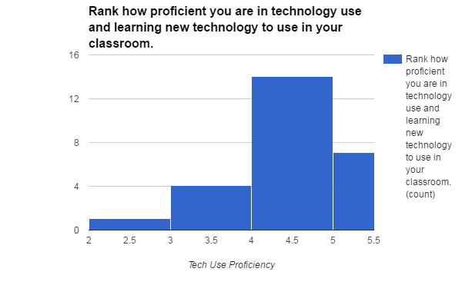
7.
8. If you ranked yourself a 3 or lower in the above question, what skills or knowledge do you need to be more proficient?

Office 365; different blog platforms Weebly, etc.
I need to be able to make some changes to my computers, such as reset the time and make adjustments more to my personal tastes; however, IT wants everything going through them.
Training in new, cool technologies to engage students- podcasts, whiteboard use, etc.
I am not based in 1 classroom so i am not familiar with the new boards
9. Do current professional learning opportunities match the skills & knowledge required to be proficient in technology use? Why or why not?

No, rarely are we provided with training for the new educational technology we receive.
Yes. We have training for new programs technology devices available to us. Mainly for testing purposes but can also be used in the classroom setting.
Yes, but the PD is not widely available and class sizes fill up. Also, not enough time given to faculty to learn resources
Not necessarily. Most of my technology aptitude comes from support from my husband who is a technology genius.
Yes, the professional learning opportunities often try to equip us with digital tools to use in the classroom and useful tools like dropbox to keep us organized.
We rarely have this kind of development
Many of the workshops only cover the basics or go through things so quickly that you can't keep up. I rarely find myself learning new technology successfully in workshops. I usually figure it out on my own or it was so user friendly a workshop was pointless.
Yes. Extensive training offered to faculty with the introduction of new technology.
I think our professional learning is limited to the almighty I-respond and pitiful tablet we have been issued. I do think the I-beam training was very good. Unfortunately the county never got around to installing mine even though my room was on the list to get I-Beam.
Yes, because technology is now so prevalent in our daily lives.
Sometimes. Technology is a means to an end. That is teaching the content
Need to offer more tech training opportunities
There are resources available. When I have asked our technology resource people for help I have gotten useful answers. Sometimes it takes too long. but we have one specialist serving several schools.
No, there are not enough hours in the day for some teachers.
Training does not equal everyday use.
No, have technology but not all can train or use
We have just this past year been assigned a Technology Trainer, Tracie Borup. She has provided some wonderful training sessions so far, but I know she has plans to provide more training specifically aimed at our local needs this next year. I look forward to that. Also, I think those training sessions should be "pushed" a little more than they have been in the past. :)
No!!! We have very limited technology training.
I am on different plu's
Yes. And I try other things on my own.
Yes if the teacher goes to conferences. Not so much at local school. Media center should provide more
Perhaps, there are such opportunities, but I am unaware of any that are consistent or effective.
I think so. I also think it takes a little bit of self-initiative as well (and practice).
Yes there is always a session on education app at every professional development.
Sometimes. Most often the professional learning is for those who are not proficient and are not beneficial.
Yes - the question is, "What technologies work best with which courses and teachers?" I've seen many technologies that I don't believe would work well in my classroom, but other teachers use it well. Similarly, I use some technologies other teachers don't.

10. 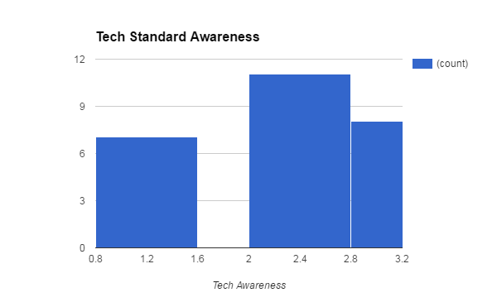
11. If you did not answer "3" in the above question, please visit this website before answering this question: (https://www.iste.org/docs/pdfs/20-14_ISTE_Standards-S_PDF.pdf) How can we do a better job of integrating student technology standards in our daily instruction?

Making students locate and use reliable electronic resources in all classes.
Plan lessons that address these standards
Digital citizenship and creative tools to enhance critical thinking
There needs to be increased awareness of these standards. If teachers are more aware of what they are, they will be more likely to integrate them into their instruction.
With more computers and programs, we can prepare our students more for the digital world by teaching them to effectively evaluate sources, maximize their time with research, and prepare them for the college classroom.
Show them to students; put in handbook
Allowing students the ability to research topics instead of just hunting for the answer to a specific question on a given website
More collaboration by subject matter teachers.
Require more outside research of our students
At this point, I don't know
by making sure it is relevant to the instruction
Including these standards in lesson plans Lang with content standards
The standards represent a well thought out integration of technology that we should strive for in our classrooms. The cynic in me feels that these standards are unobtainable with the current state of tech in our system. To obtain these goals students will need constant access to good tech. Not iResponds.
Question of the Day
Hey, I answered 3!
Use technology and professional partners to solve real problems, not just a mock up
I think classroom teachers should work closely with their Media Specialists to get help in making plans for lessons in order to integrate technology. These people are BUILT IN support for that type of collaboration, but they are often overlooked as resources. Also, Tracie Borup, (our technology trainer) would be a marvelous resource for teachers to use in developing integrated instruction.
We need ready access to technology that works.
Most of our kids have access to Internet and computers, however we all have kids who don't. Some English classes do an amazing job if teaching Google drive. I think we should also have class sets of thumb drives.
Working with others globally
Be aware, maybe have a tech day or include in ase
Ensuring that the student technology standards are integrated can only happen through awareness by teachers that there are such standards. Visibility is key, but teachers' comfort levels in using technology is crucial in effective implementation of this issue.
I mean in the English department, we have to integrate use of technology according to the Common Core Standards, but I didn't know that document existed. We typically address those standards (though possibly unintentionally) when we do research papers. I also know that we have the students create PowerPoints, digital art, etc. for presentations.
Instead of teaching us that technology is important, give some concrete examples of how we can use it (as opposed to general examples)
Teachers should be made aware of these standards. Implementing is not difficult if you know what you are doing.
Teachers need to be aware of these standards!

